Merkinch Local Nature Reserve
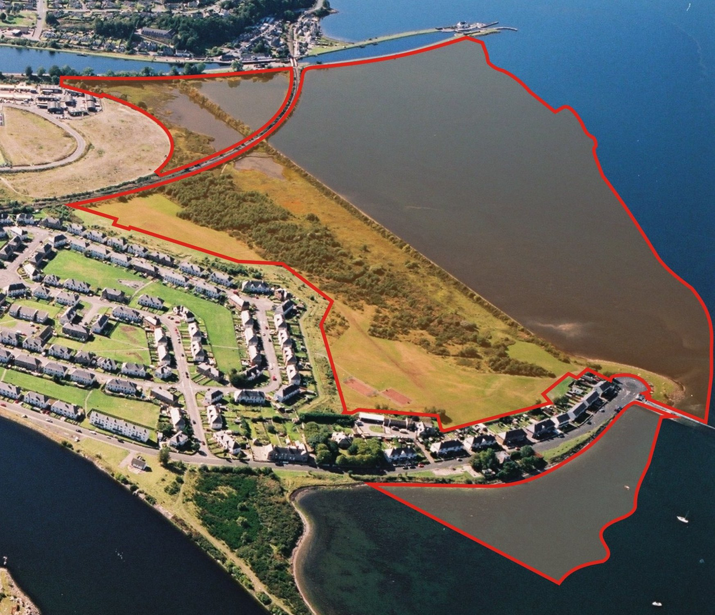
The open area between the Caledonian Canal and the Old Ferry is now a LOCAL NATURE RESERVE.
MERKINCH GREENSPACE would like to find out what you think about this area, whether you use it and what would make it a better place.

1. Are you aware that this area has been designated a Local Nature Reserve?

Yes 74%……………………….. No……26%…………………

2. What do you know about the Reserve?

Most common answers:
Information from News and Views
Exhibition of photos
Wildlife – deer, rabbits, birds, plants, flowers, improvements.

3. How often do you visit the Reserve?
Never – 32%
Regularly (weekly/monthly) – 47%
Rarely – 21%

4. What do you visit the Reserve for
In order of popularity:
Recreation – picnics, photography, wildlife, walking, family time, scenery.
Walking the dog
One off events
Cycling

